

COMPUTER SCIENCE DEPARTMENT

Total Marks:
Obtained Marks:

Computer Networks and Data Communications

Labtask -09

Submitted To: Sir Ammad Noor

Student Name: Ubaid Bin Waris

Reg Number: 2212416

COMPUTER SCIENCE DEPARTMENT

Static NAT

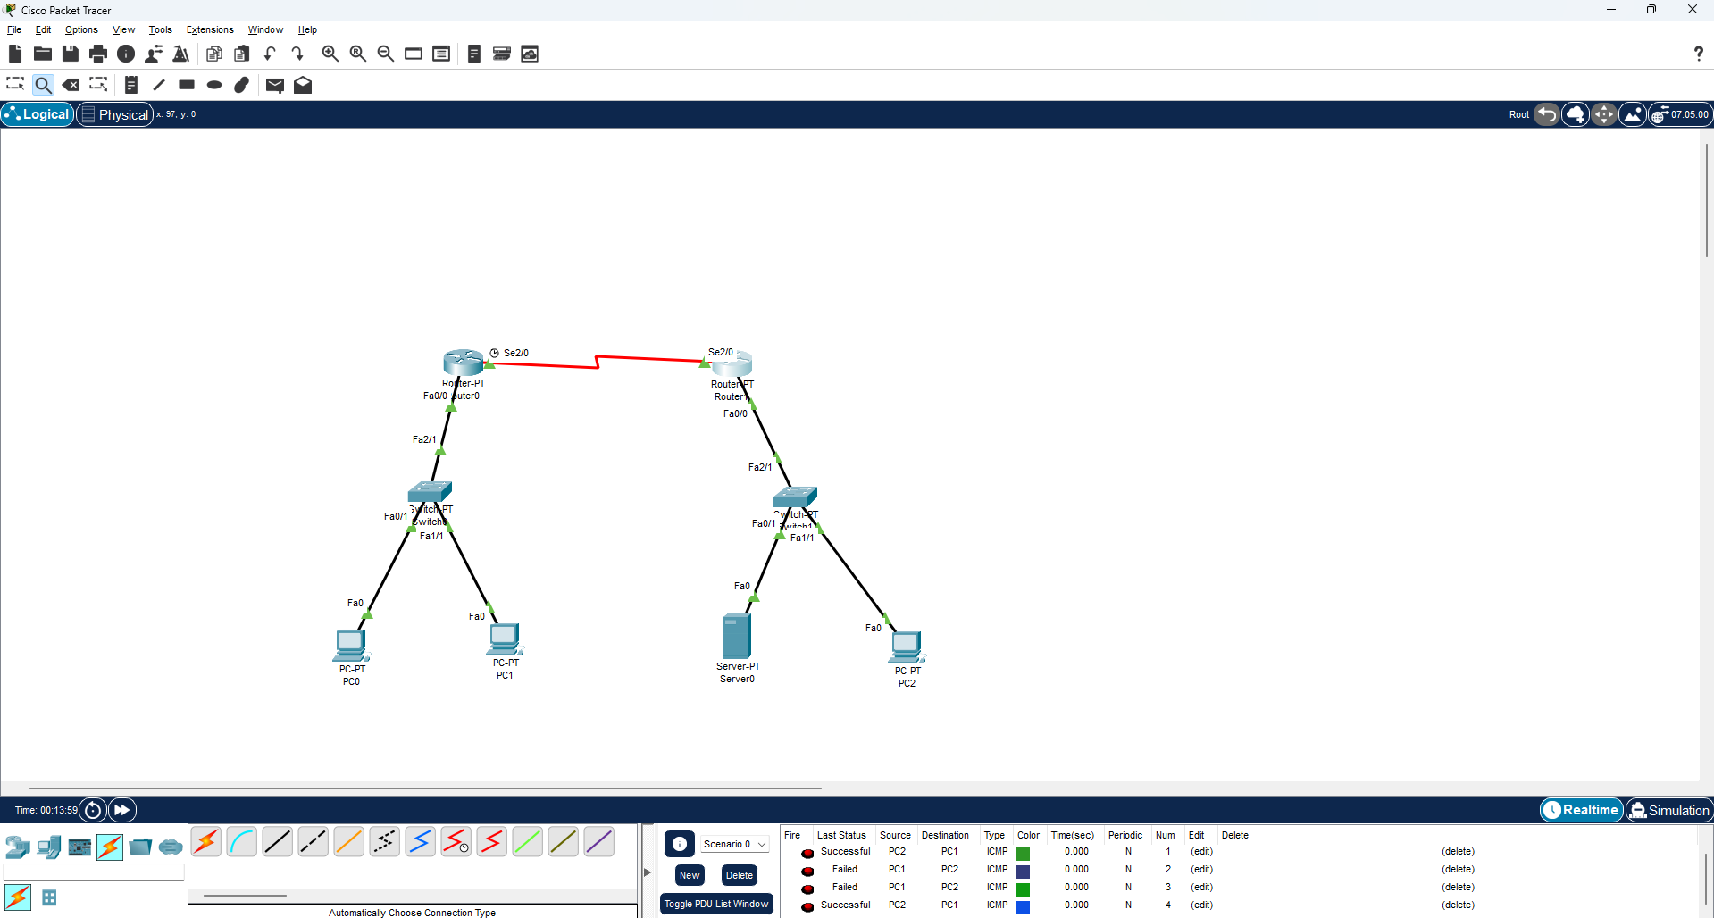

Dynamic NAT

